What does it look like to work with Monica Wales

as YOUR Ramsey Preferred Financial Coach?

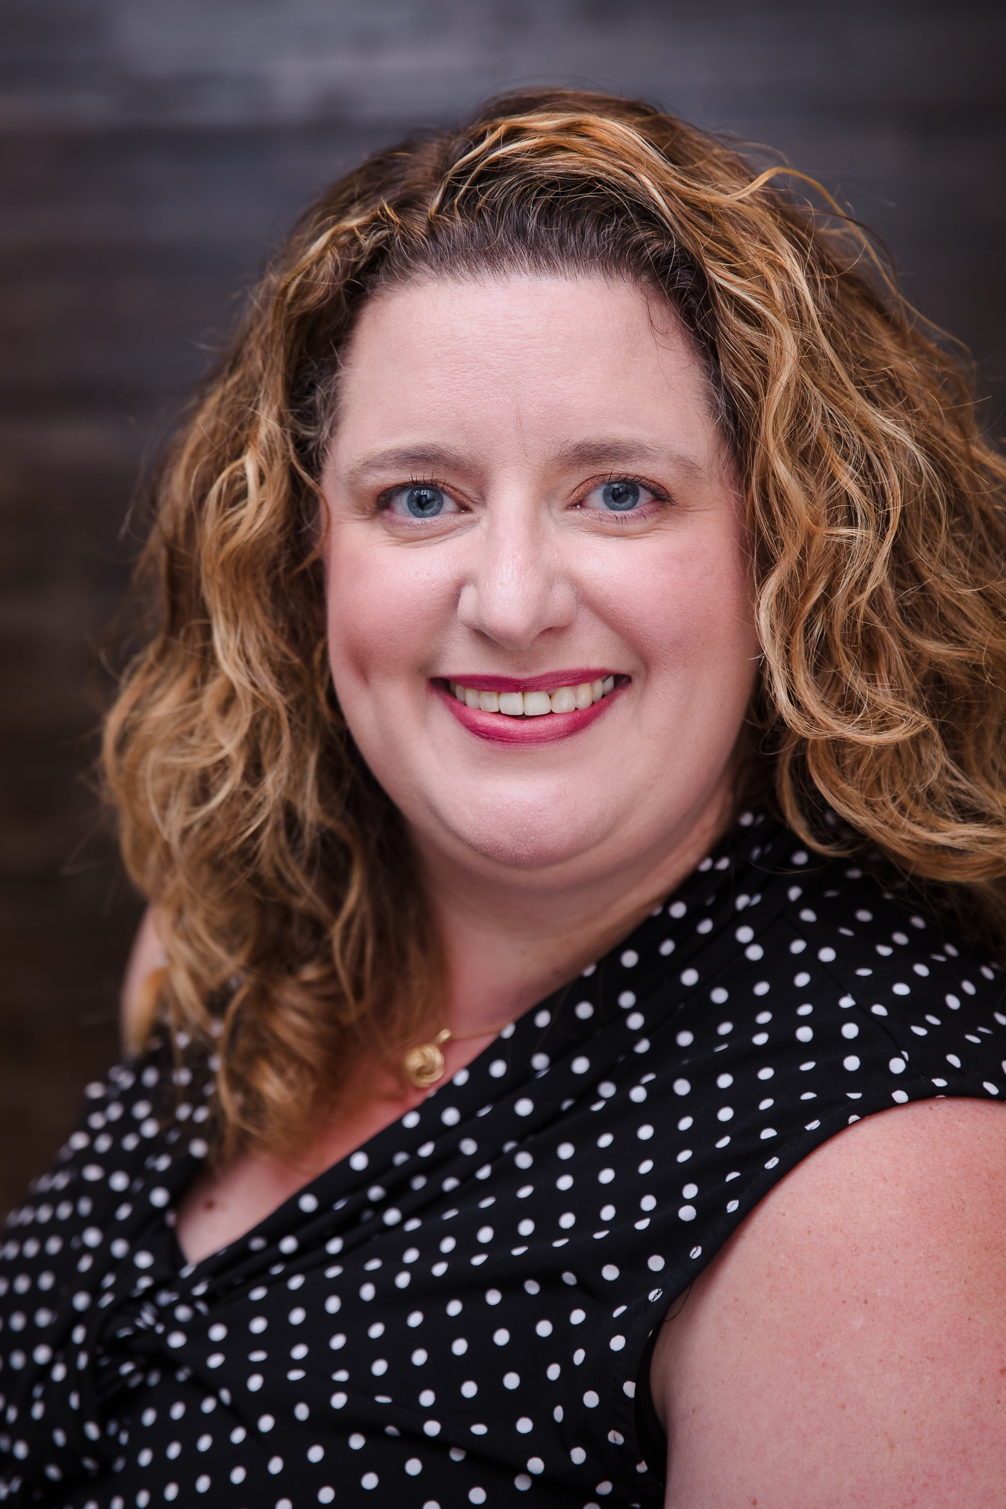

What you get as a client:

* (1) hour powerful and virtual financial coaching sessions per month.
* A personalized mid-month check-in email or text message from Monica.
* Access to Ramsey tools.
* Coaching Freedom resources as developed exclusively for YOU.
* Monthly issue of the *Freedom Flyer.*
* Discount on annual Ramsey+ subscription.
* Access to Preferred Providers in various industries related to your money.
* Ask powerful questions to help you identify answers for yourself.

As YOUR coach Monica will:

* Challenge you to seek alternative strategies without judgement or shame.
* Provide recommendations and encouragement.
* Hold you accountable & CELEBRATE wins along the way.

To get started:

* [Register for your first financial coaching session](https://square.link/u/f58fb7Z6).
* Complete a Client Information Sheet.
* Schedule your Client Welcome Call.
* Schedule your first financial coaching session.

If you want to learn more about me and why we should work together:

* Trained by members of the Dave Ramsey team to help people like you walk through the Baby Steps so that you can live out your life and financial dreams and goals.
* Invests in coaching for herself.
* Walked through all the Baby Steps with her husband.